BANK!

A Block Pushing Puzzle Game
by Christopher Moore

Goal

The goal of Bank is to collect all the money bags in each level. Only then does the key activate. Then you can collect the key and complete the level.

Game Play

 - This is you. Your job is to first get all the money, then get they key, and then you can move on to the next level. You can move with the arrow keys and place bombs with configured-Y button. If you ever get stuck you can restart the level with the configured-X button.
 - This is the ground. You can walk on it.
 - This is money. You need this because there's an economic recession.
If money has a number on it then it contains a bomb, and getting the money will give you as many bombs.
- This is the key.
If it's grey then there's still money you need to get.
But if it's gold then you can touch it to end the level.
 - This is a bomb.
Some bombs will be already placed in the level, and some bombs can be collected by picking up money.
All bombs can be pushed.
If you collect a bomb from money then you can drop it with the configured-Y button.
If you drop a bomb then it is lit and will detonate in a few short seconds.
A bomb will have a number on it. The number says how many tiles in each cardinal direction that the bomb will blast.
If you are standing on one of these blast squares then you'll die.
If another bomb is on a blast square then it will get lit.
 - This is an emerald framer, I mean, a push-block. You can push it. It stops bomb blasts and enemy shots.
 - These are bricks. You can't walk through them. But you can destroy them with bombs.
 - This is a tree. It's tough. You can't destroy it with a bomb. But your bomb blasts will go through it.
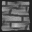 - This is stone. It's tough. You can't even destroy it with a bomb. It will stop bomb blasts.
 - This is heavy water. You can't swim in it (Google it). But if you push a bomb in it, the bomb will float, and you can walk on the bomb. But after some time the bomb will sink.
 - This is a gun. It shoots in the 4 cardinal directions. It can shoot through trees, but not through bricks or stones or push-blocks. Bombs can't kill it.
 - This is a sentry. When it hits a wall it turns left. Bombs can't kill it, but they will stop its movement.

Controls

Press Esc at any time to return to the main menu.

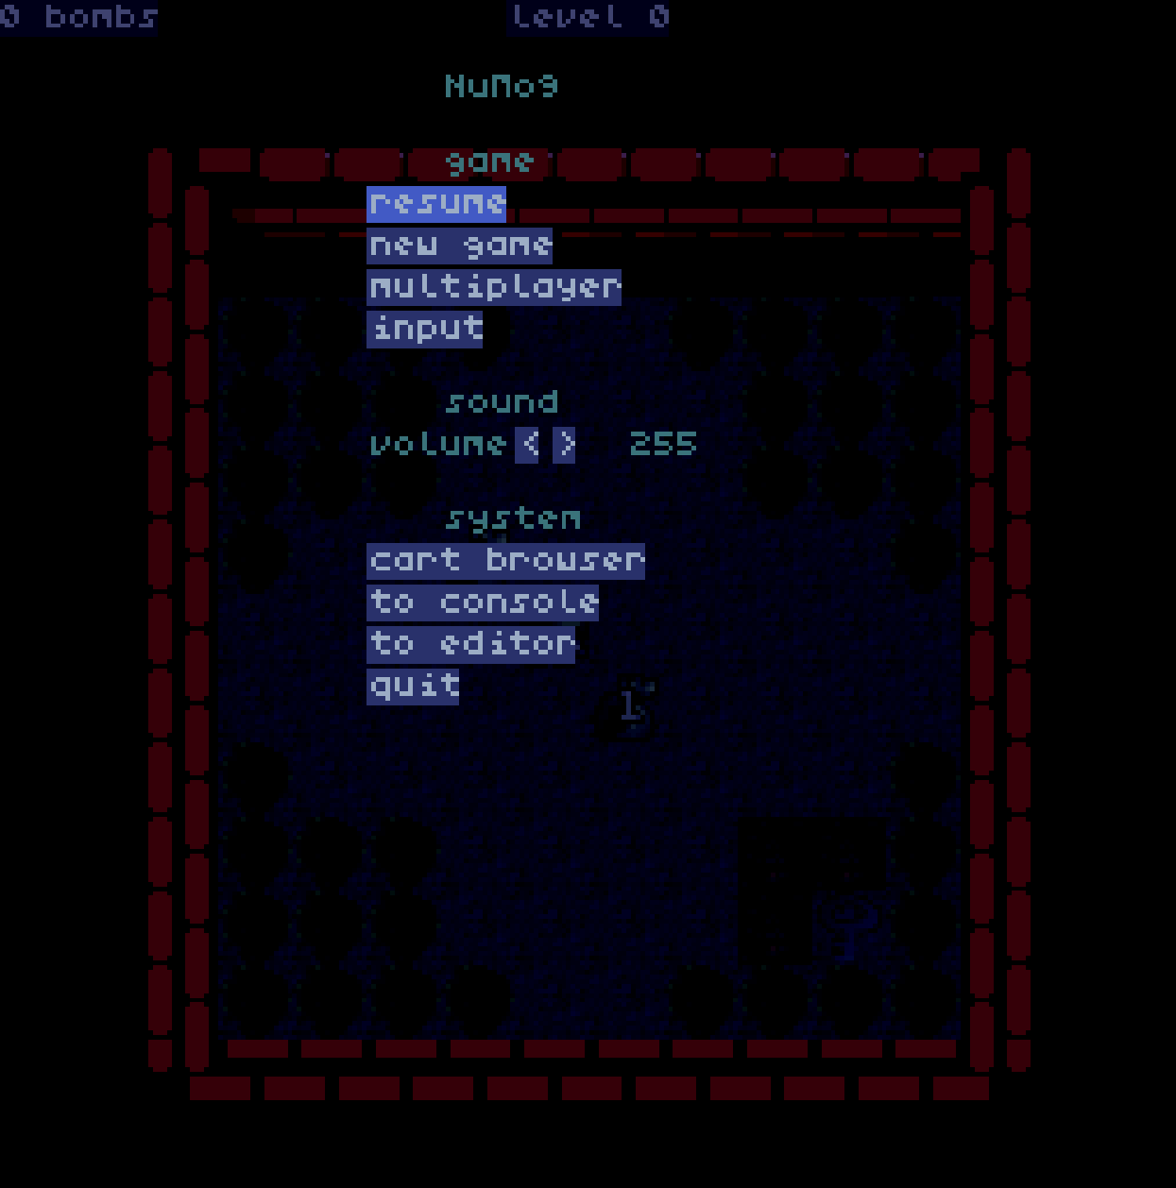

From there you will be able to resume your gameplay, reset the game, adjust the volume, configure your input keys, etc.

Input

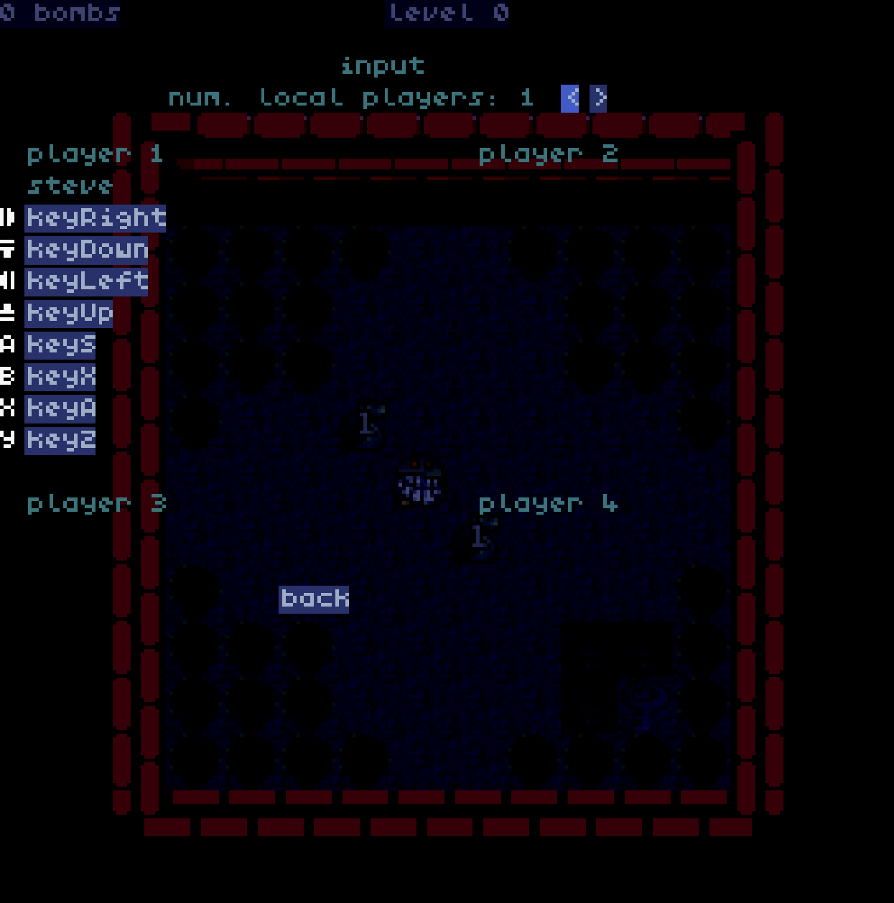

Notice that the subsequent gameplay descriptions will refer to keys such as “A”, “B”, “X”, “Y” – these refer to controller-labeled key names and not keyboard keys. Included is a screenshot of the default key bindings but feel free to adjust the keys as you see fit.

Editor

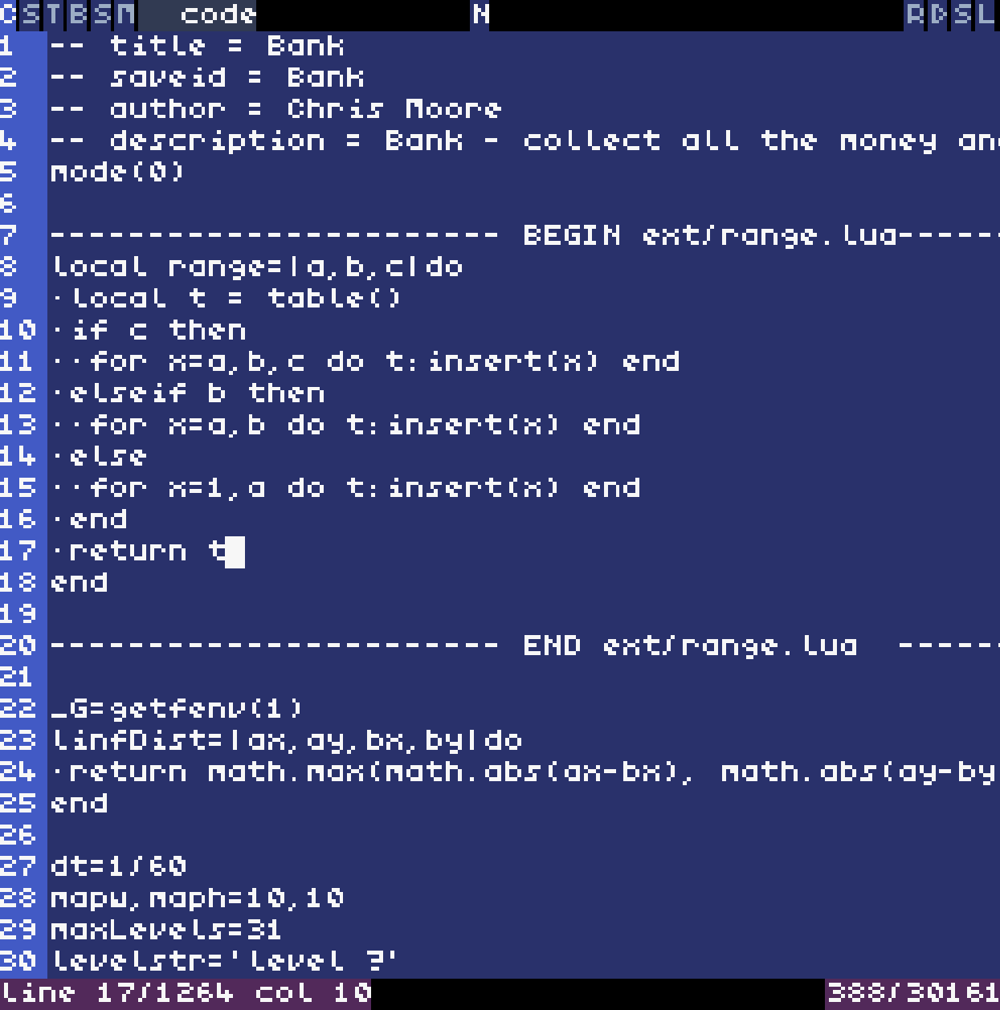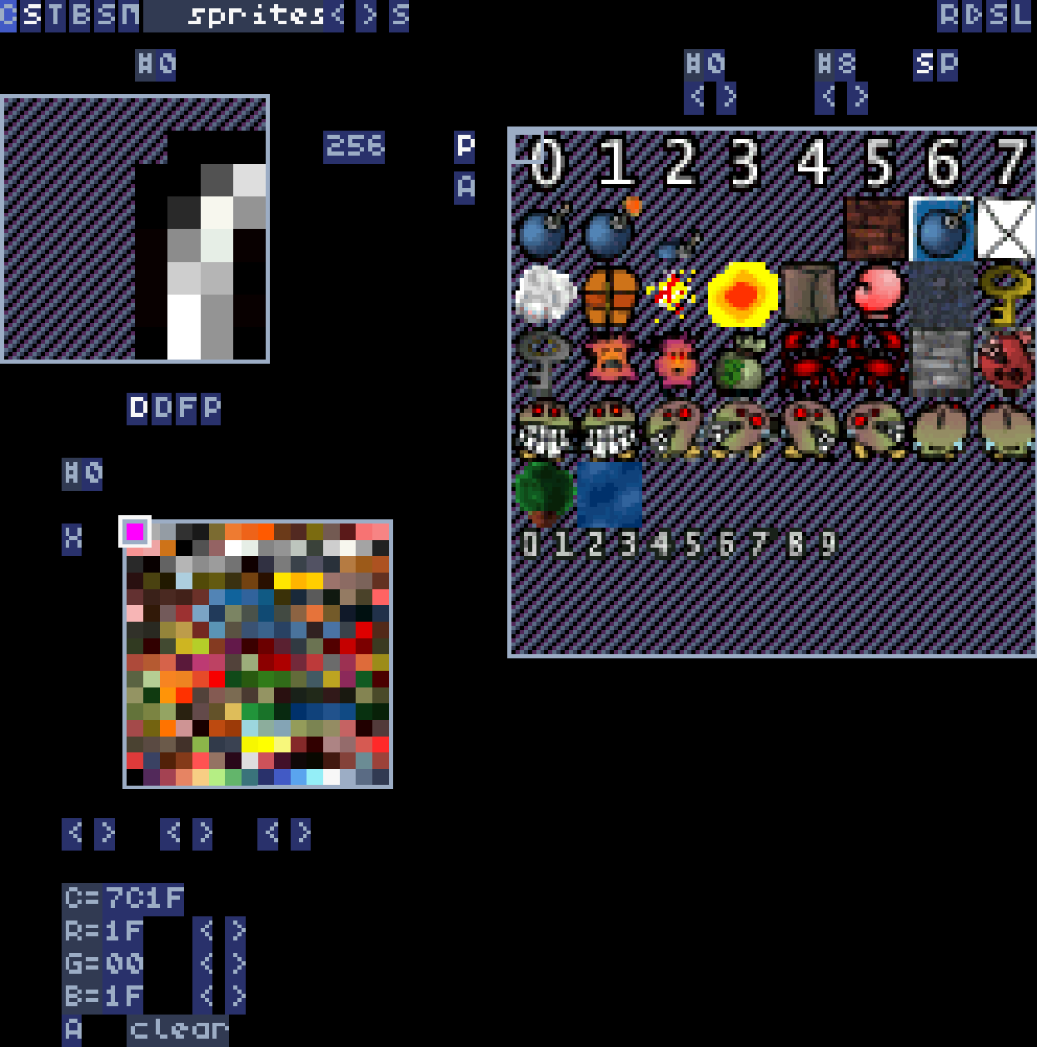

There is a built-in editor, but it is not an editor for only this game – instead it is an editor for the fantasy-console designed to run this game. From this you can fully edit any aspect of the game – levels, sprites, sounds, code, etc.

Fantasy Console

This game is a debut of my fantasy console, NuMo9. The design goal of this console was to code it as much in LuaJIT as possible, LuaJIT being the scripting language behind nginx, Torch7, and many other performance-centric scripted applications. The hardware level I decided to target was the 90s / SNES era. For more on NuMo9, check out its website here: https://github.com/thenumbernine/numo9

Thank You

